The Setup Steps and Use of Common Software
1 Install the PC common software. Find the setup of PC software, and directory list box is as shown below. Double click the icon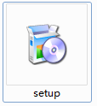, and then click the button “Next step” according to the tips of the setup guides, at last the PC common software is installed successfully.
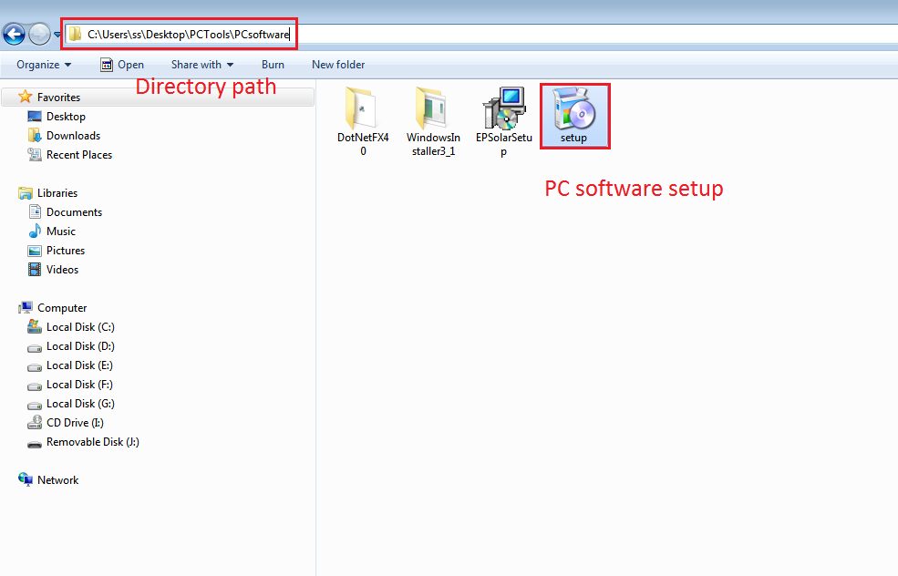
2 Connect the communication line between PC and controller. Communication line is special for PC and controller. Use its USB port plug in arbitrary USB port of PC, and the other port plug in corresponding port of controller (RS485 or TTL), the sketch map is as shown below:
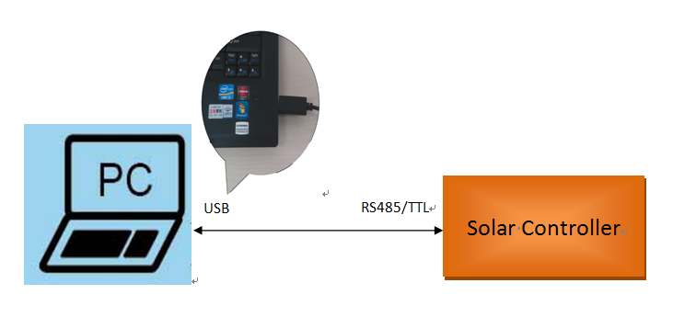
3 Install the driver of communication line. Double click icon file 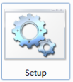 in the setup of driver, system will install the driver of communication automatically, the directory list box of driver is as shown below.
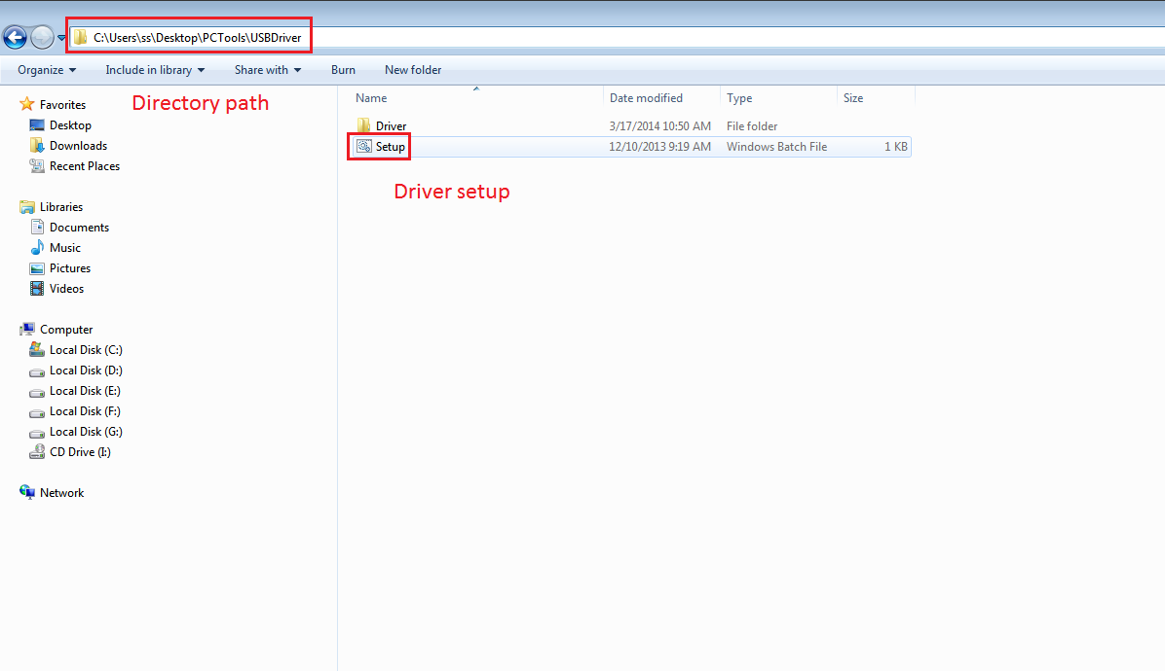
(1)If the model of current line is CC-USB-TTL-150U (you can check model label on the line), you need find the driver information of corresponding line. Double click the information and its attribute dialog pops up as shown below. Please affirm that the state of “RS485” option is not checked in the page of “Port Setting”.
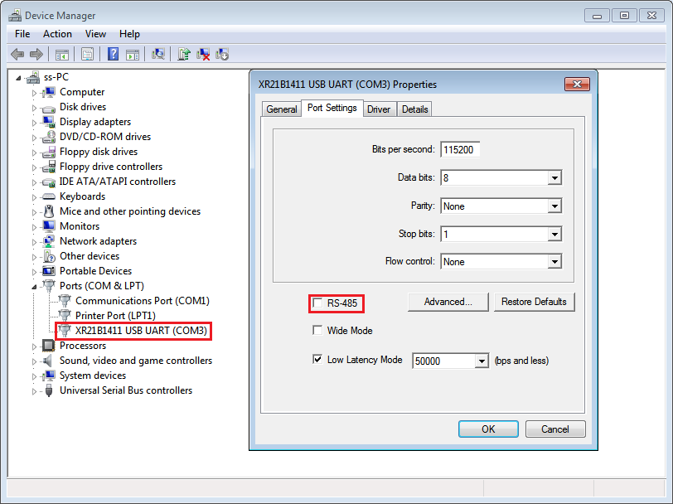
(2)If the model of current line is CC-USB-RS485-150U, you can check the state of “RS485” option as same as CC-USB-TTL-150U The attribute dialog of “Port Setting” pops up as shown below, please affirm that the state of “RS485” option is checked in the page of “Port Setting”.
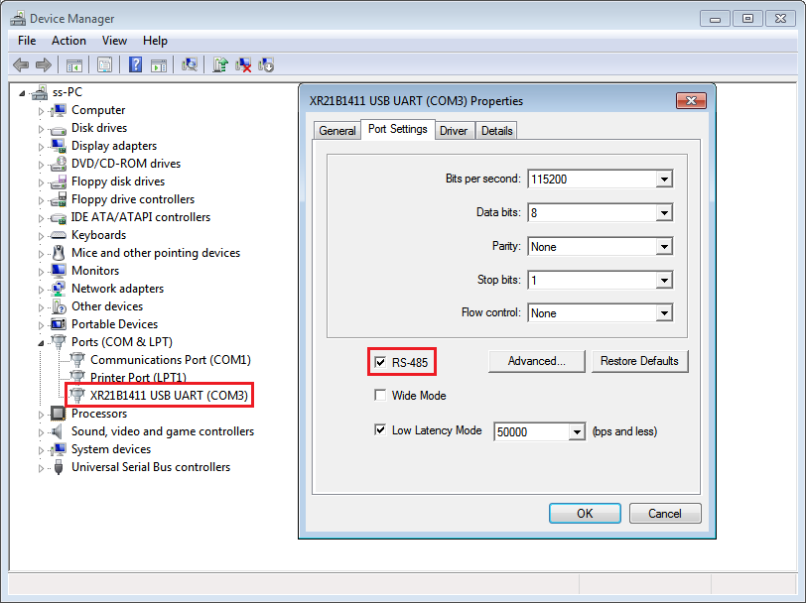
4 Use the PC software. After install the PC software and the driver, you can run PC common software. Click the “Solar Station Monitor” icon, and enter into the operation steps as below:
(1)” Log In” interface is popped up, the user name and correct password have been filled in, and directly click the button “Log In” to enter the main interface of PC monitoring software. The “Log In” interface and main interface is as shown below:
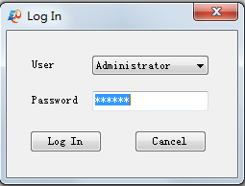
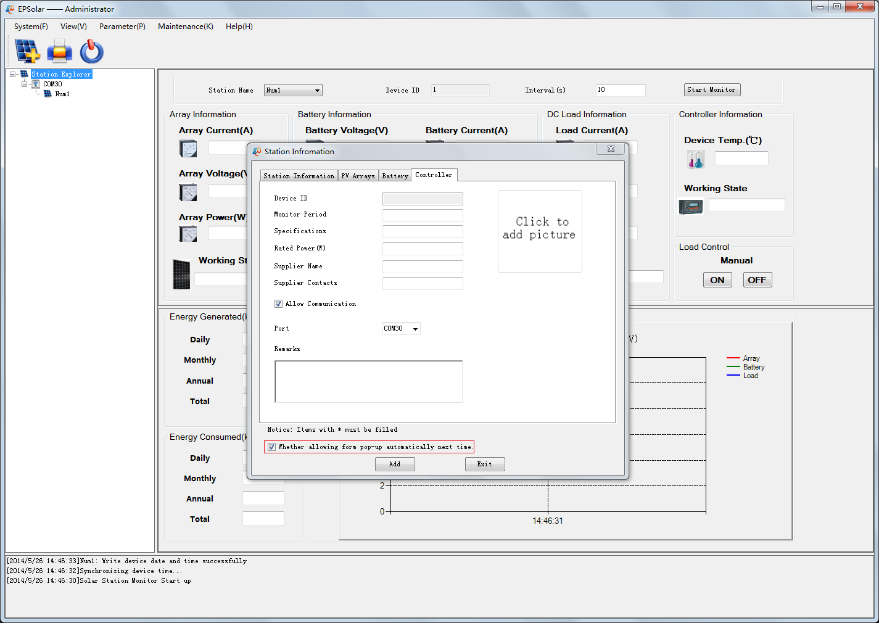
Notes: After logging in , the station information dialog pop up automatically as same as the main interface, and you can set whether the station information dialog pop up below the dialog.

(2)Add station information. The Station information has been filled in on the simplified version of PC monitoring software. Just select the station port and click the button “Add”, you will add station successfully.
Notes: Device ID default is 1 in the station information (Controller ID of factory default is 1). When you add the station, you must check station information correctly. In addition, select the correct communication port in the page of “Controller” information (The port corresponds with the port of communication line), otherwise lead the controller and the PC software to communicating incorrectly.
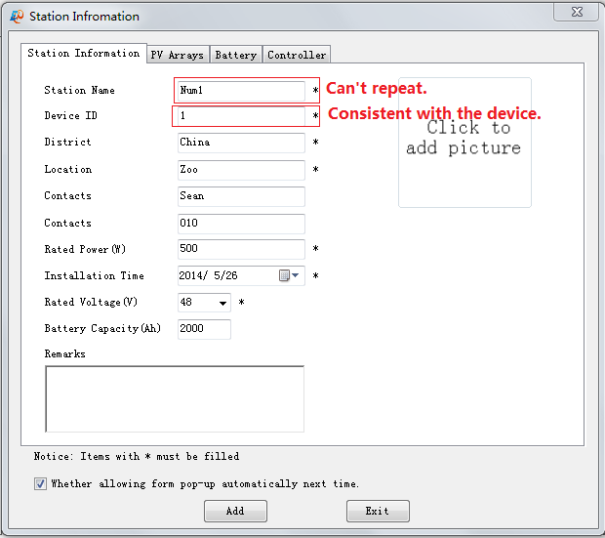
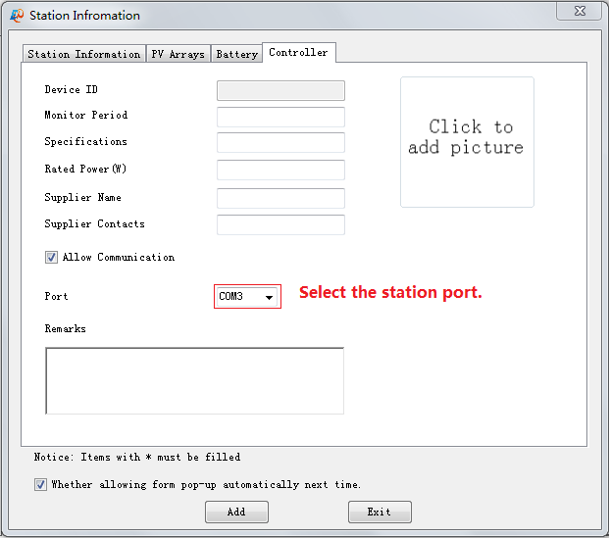
(3) Start up the real-time monitoring. Click the button “Start monitor” to enter into monitoring the controller and looking over the real-time monitoring data, operating interface is as shown below:

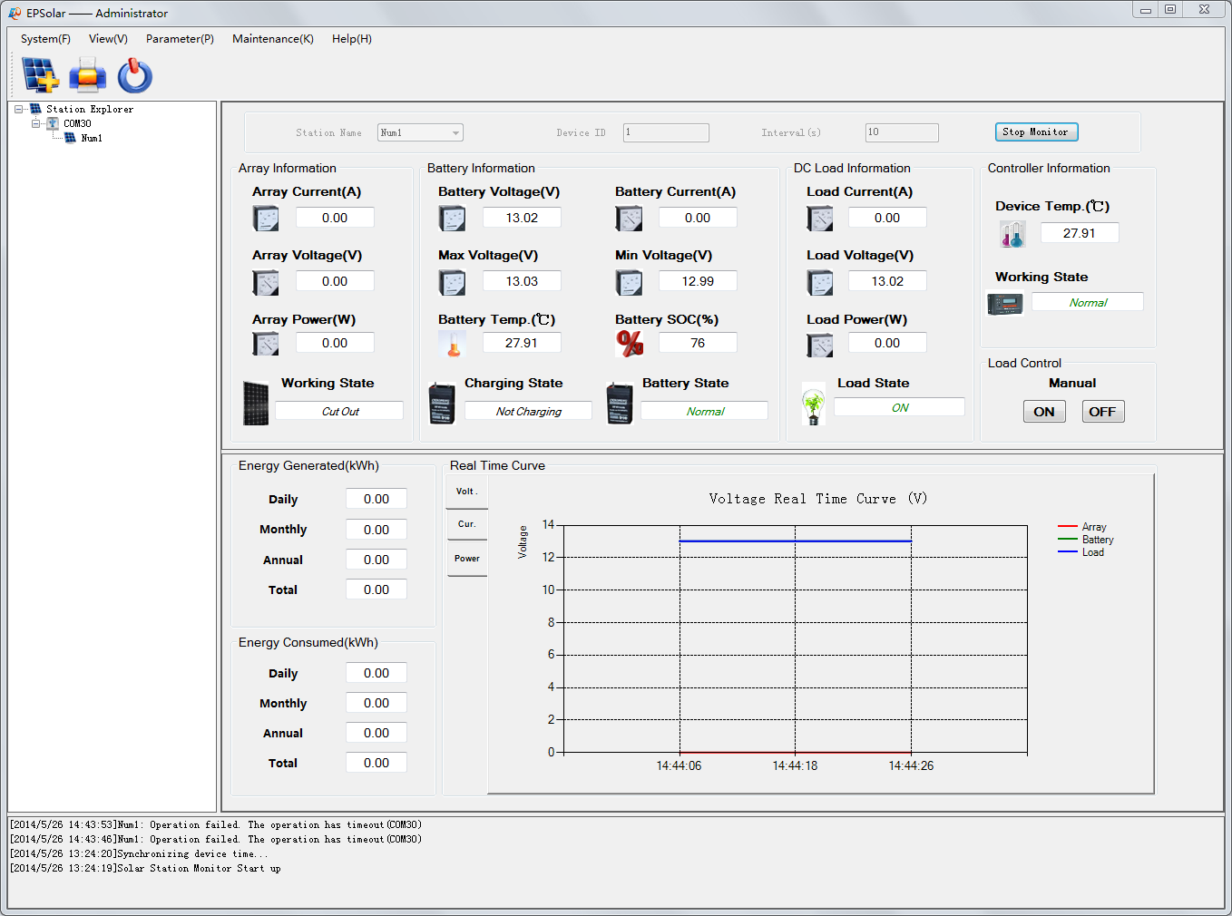
Notes:
- The help document in the menu bar “Help(H)->Help” explains the other operation of PC software in detail.
- Because different language windows systems have different character format, you can check the region and language setting and set Enlish language and region in the "Menu>ControlPanel>Region&Language>Format". This will help you use our software normally.

